What is JavaScript?
JavaScript is a high-level, interpreted programming language that is mainly used to make web pages interactive and dynamic.
Here are the key points about it:
- Web Focused: It runs in web browsers and allows developers to add behaviors to websites (e.g., dropdown menus, pop-ups, sliders, animations).
- Event-Driven: Reacts to user actions like clicks, typing, or scrolling.
- Client-Side: Primarily executes on the user’s device inside the browser (though with Node.js, it can also run on the server side).
- Interpreted Language: Doesn’t need to be compiled separately; browsers execute it directly.
- Works with HTML & CSS: HTML structures the content, CSS styles it, and JavaScript adds logic/interaction.
Example:
If you press a button on a webpage and a message pops up, that’s usually JavaScript at work.

How do you include JavaScript in an HTML file?
There are two way to include js file in HTML file
- Internal javascrip
When you including internal js file then you need to use <script > tag only and inside the body but at last .
- External javascript
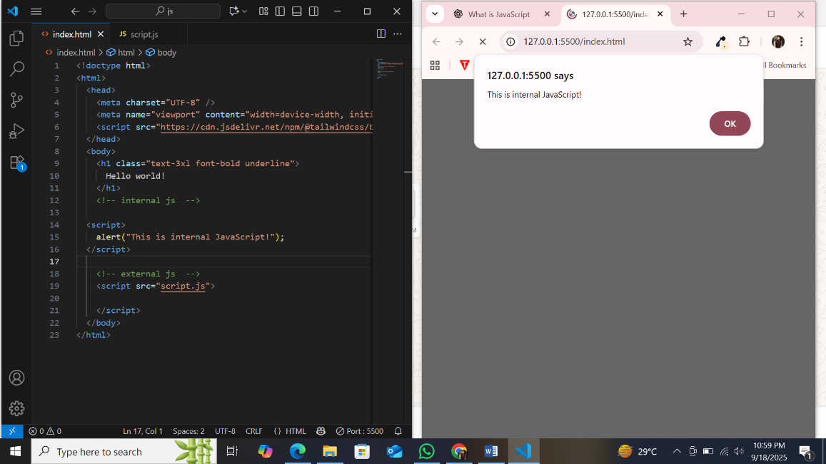
When you including internal js file then you need to use <script > tag only and inside the body but at last .

What is console.log() used for?
console.log() is a JavaScript function used to print (or display) messages in the browser’s console
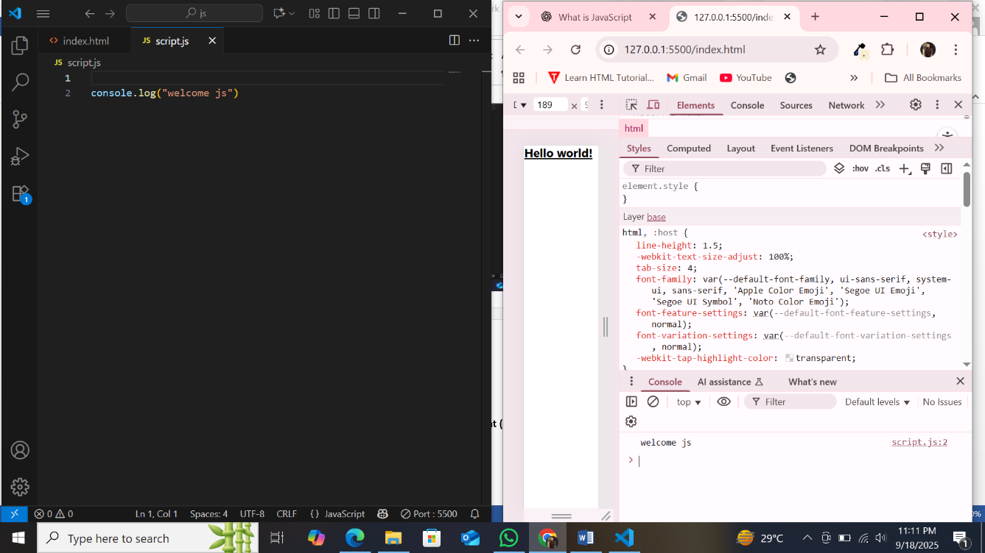

What is an alert box in JavaScript?
An alert box in JavaScript is a popup dialog box that shows a message to the user.
It is created using the alert() function.
Key points:
- Displays a message in a small popup window.
- Only has an OK button (user must click it to continue).
- Often used for giving information or warnings.
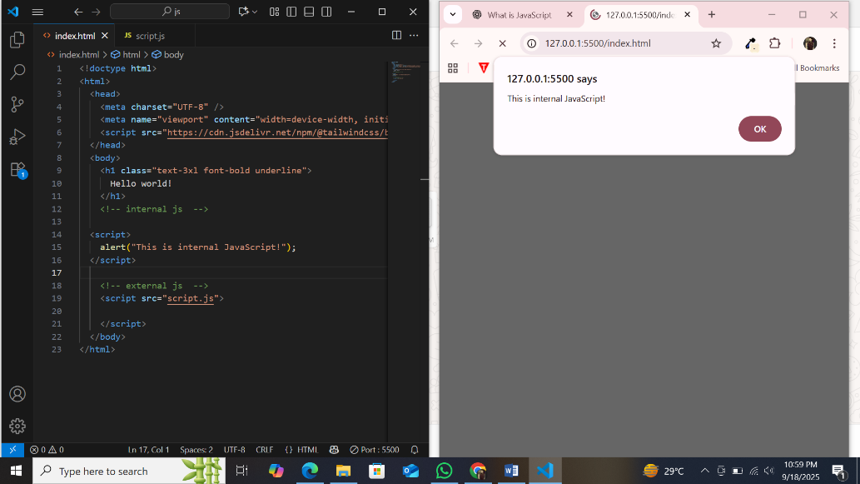
Write a script to display an alert box with the message "Welcome to JavaScript!"

Name some popular JavaScript frameworks and their uses.
popular JavaScript frameworks and libraries with their main uses 👇

1. React.js (library, often treated like a framework)
- Developed by Facebook.
- Used for building user interfaces (UI), especially single-page applications (SPA).
- Component-based, fast, and widely used.

2. Angular
- Developed by Google.
- A full-fledged framework for building large, complex web applications.
- Supports two-way data binding and MVC architecture.

3. Vue.js
- Lightweight, easy-to-learn framework.
- Used for interactive UIs and single-page apps.
- Combines features of React and Angular.

4. Node.js (runtime environment, not exactly a framework)
- Allows JavaScript to run on the server-side.
- Used for backend development, APIs, and real-time applications.

5. Express.js (built on Node.js)
- A backend framework for building web servers and APIs.
- Simple, minimal, and fast.
What is the MERN stack?
The MERN stack is a popular set of technologies used for full-stack web development.
It includes four main components:

M – MongoDB
- A NoSQL database.
- Stores data in JSON-like format (documents).

E – Express.js
- A backend web framework built on Node.js.
- Used for building APIs and handling server logic.

R – React.js
- A frontend library for building user interfaces.
- Creates dynamic and interactive web pages.

N – Node.js
- A runtime environment that allows JavaScript to run on the server side.
- Handles server requests and executes backend code.
Compare JavaScript and PHP.

1. Language Type
- JavaScript → Scripting language, mainly used for client-side (browser) but also works on server-side with Node.js.
- PHP → Scripting language, mainly used for server-side development.

2. Execution
- JavaScript → Runs inside the web browser (client), or on the server with Node.js.
- PHP → Runs only on the server, generates HTML which is sent to the client.

3. Use Cases
- JavaScript → Interactive websites, frontend logic, dynamic content, animations, real-time apps.
- PHP → Server-side logic, form handling, database interaction, building web apps like WordPress.

4. Database Handling
- JavaScript → Uses Node.js with databases like MongoDB, MySQL, PostgreSQL.
- PHP → Commonly paired with MySQL or MariaDB.

5. Syntax
- JavaScript → Syntax is C-like, flexible for frontend + backend.
- PHP → Syntax is more similar to C but designed for embedding in HTML.

short answer:
JavaScript is mainly a client-side language (can also run on server with Node.js) used for interactivity.
- PHP is a server-side scripting language used for backend tasks like database handling and dynamic page generation.

